**Master SpringBoot**

**06-HATEOAS implementation:**

**Step-00: Create new GIT branch for HATEOAS**

* **git branch –vva**
* **git status ( make sure you are on master )**
* **git checkout –b 07-SpringBoot-HATEOAS**
* **git push –set-upstream origin 07-SpringBoot-HATEOAS**
* **git branch –a**

**git branch -vva**

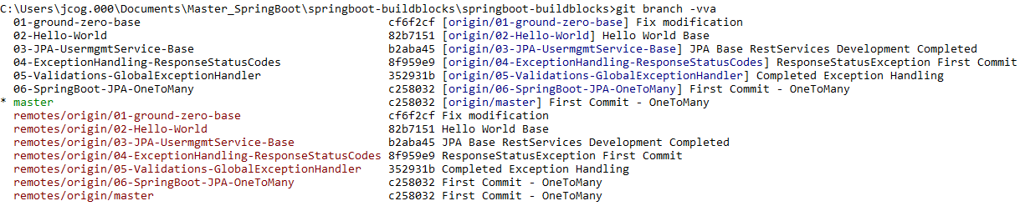

**git status**

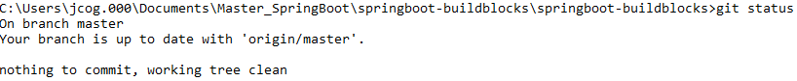

**git checkout –b 07-SpringBoot-HATEOAS**



**git push –set-upstream origin 07-SpringBoot-HATEOAS**

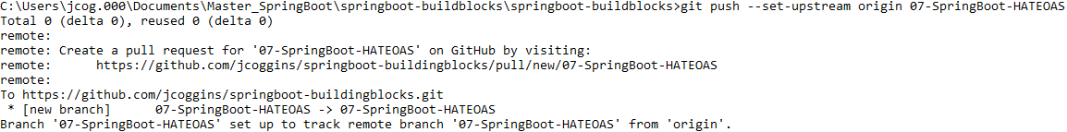

**git branch –a**

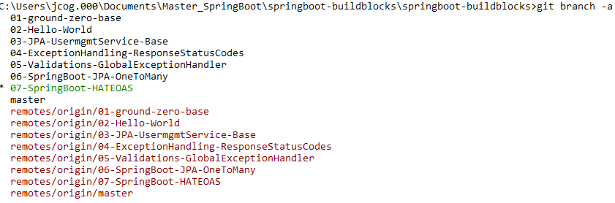

**Local branch and remote branch are the same**

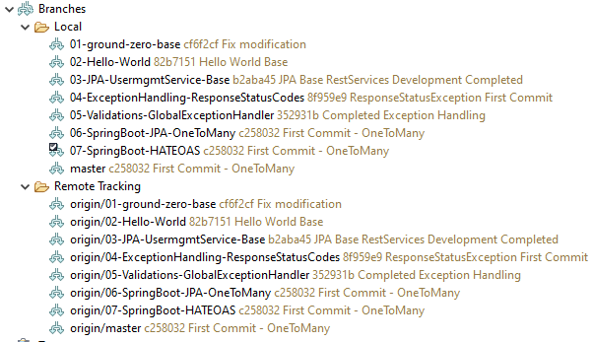

**Step-01: Add Dependency in pom.xml**

* **Add dependency in pom.xml (spring-boot-starter-hateoas**
* **Restart SpringBootApp (to reflect new dependency changes – new jar added)**

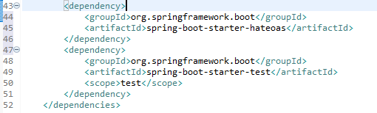

**Restart SpringBootApp**

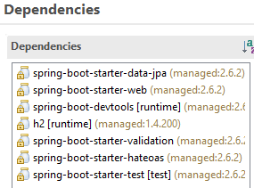

**Step-02: Extend both Entities to ResourceSupport**

* **Entity Layer**
  + **User extends ResourceSupport (** RepresentationModel **)**
  + **Order extends ResourceSupport (** RepresentationModel **)**

[**https://docs.spring.io/spring-hateoas/docs/current/reference/html/#fundamentals.obtaining-links.entity-links**](https://docs.spring.io/spring-hateoas/docs/current/reference/html/#fundamentals.obtaining-links.entity-links)

* ResourceSupport is now RepresentationModel
* Resource is now EntityModel
* Resources is now CollectionModel
* PagedResources is now PagedModel



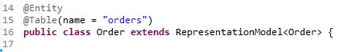

**Step-03: Create new User and Order Controllers for HATEOAS Implementation**

* **UserHateoasController**
  + **Create new UserHateoasController**
  + **Annotate with @RestController**
  + **Annotate with @RestMapping(value = “/hateoas/users”)**
  + **Annotate with @Validated**
  + **Autowire Respositories (UserRespository)**
  + **Copy Methods getUserById, getAllUsers from UserController**
* **OrderHateoasController**
  + **Create new OrderHateoasController**
  + **Annotate with @RestController**
  + **Annotate with @RestMapping(value = “/hateoas/users”)**
  + **Annotate with @Validated**
  + **Autowire Respositories (UserRepository, OrderRespository)**
  + **Copy Methods getAllOrders from OrderController to OrderHateoasController**
* **Test with POSTMAN**
  + **getUserById**
    - **GET /hateoas/users/{id}**
  + **getAllUsers**
    - **GET /hateoas/users**
  + **getAllOrders**
    - **GET /hateoas/users/{id}/orders**

**UserHateoasController**

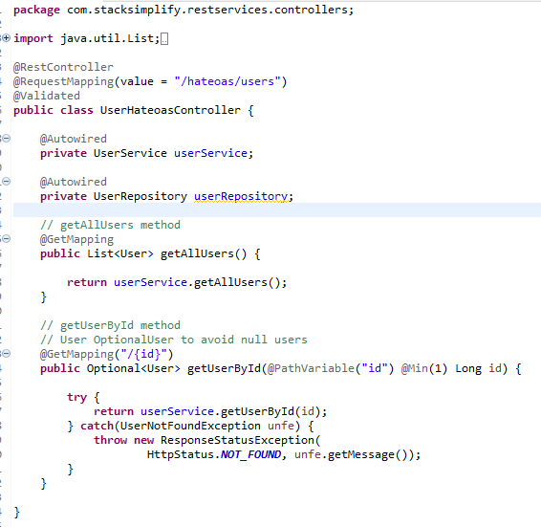

**OrderHateoasController**

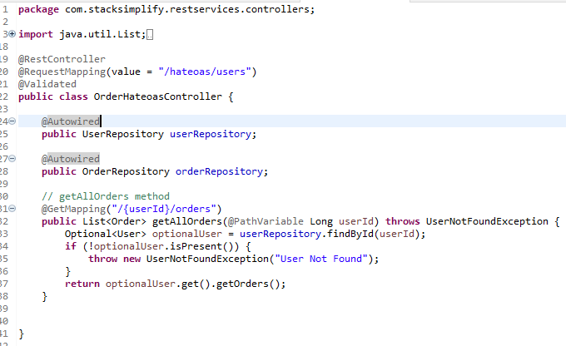

**Notice links on users getAllUsers**

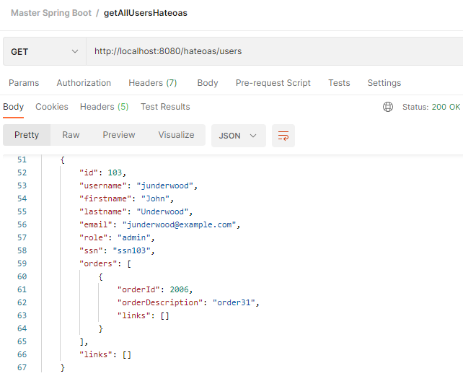

**getUserByIdHateoas**

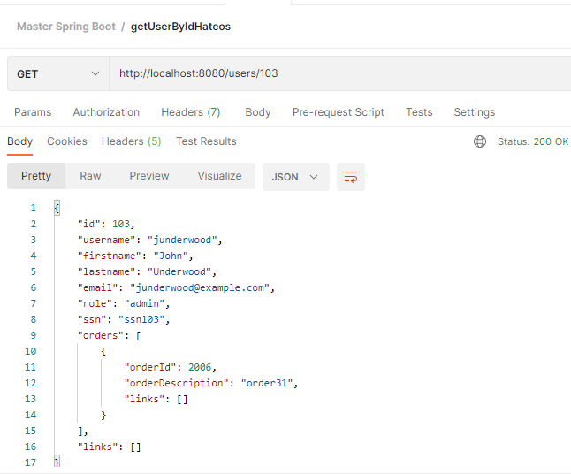

**getAllOrdersHateoas**

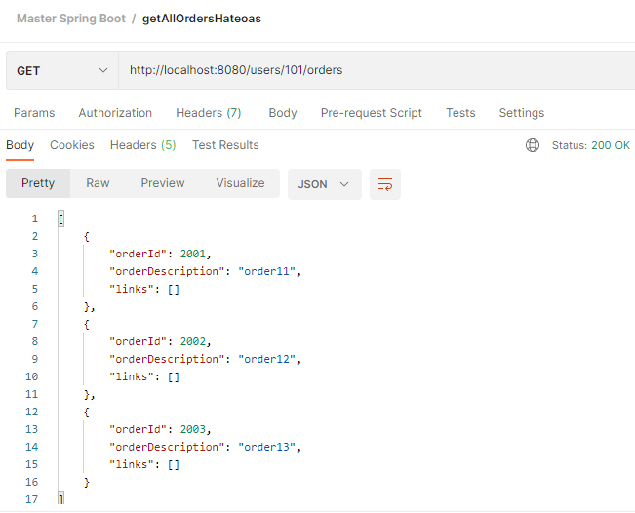

**Step-04: Implement self link in getUserById Method**

* **UserHateoasController**
  + **getUserById – Self Linking**
  + **Method: getUserById**
    - **Extract Id**
    - **Create Link using ControllerLinkBuilder (** WebMvcLinkBuilder )
    - **Add Link to Resource**
    - **Instead of User return Resource<User> (Return Type changed to Resource)**
* **Test using POSTMAN**
  + **Method: getUserById**
  + **GET /hateoas/users/{userid}**

Note:

ControllerLinkBuilder has been moved into server.mvc and deprecated to be replaced by WebMvcLinkBuilder.

**UserHateoasController populating Link for getUserById():**

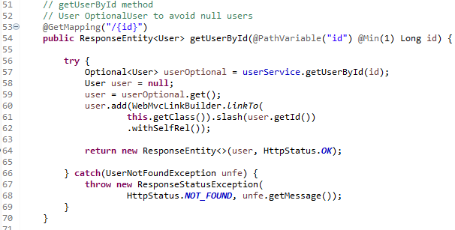

**Test using POSTMAN:**

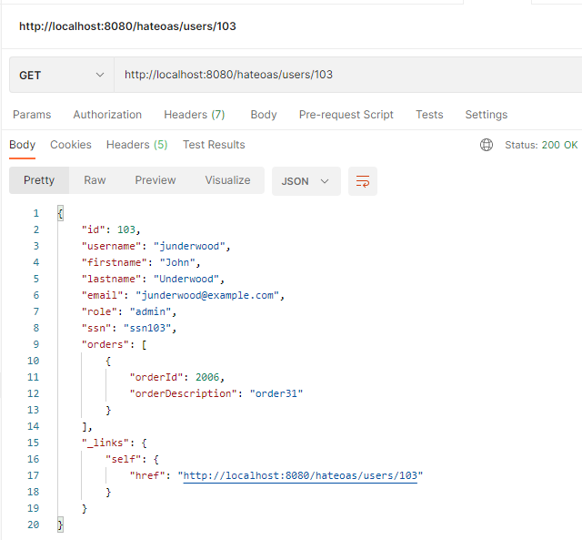

**UserHateoasController populating Link for getAllUsers():**

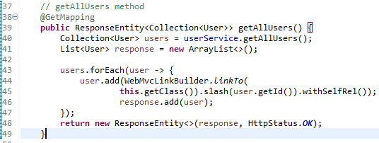

**Test using POSTMAN:**

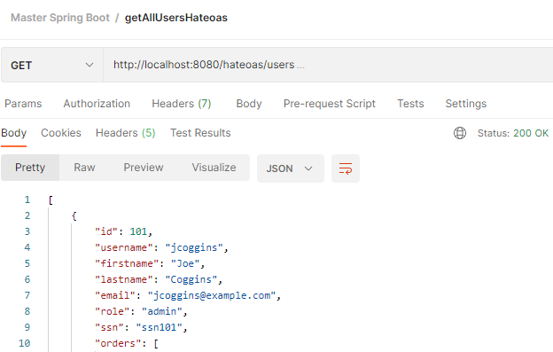

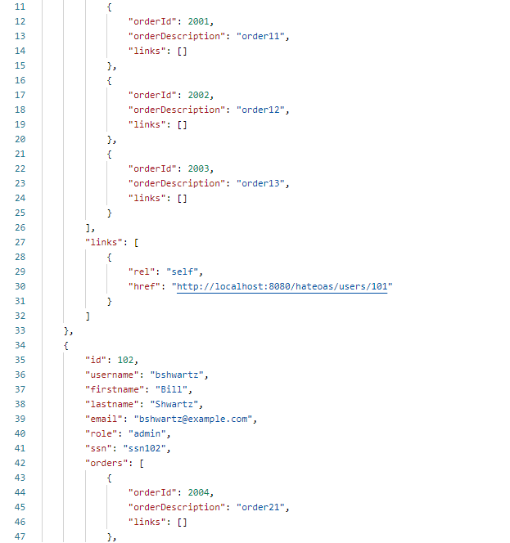

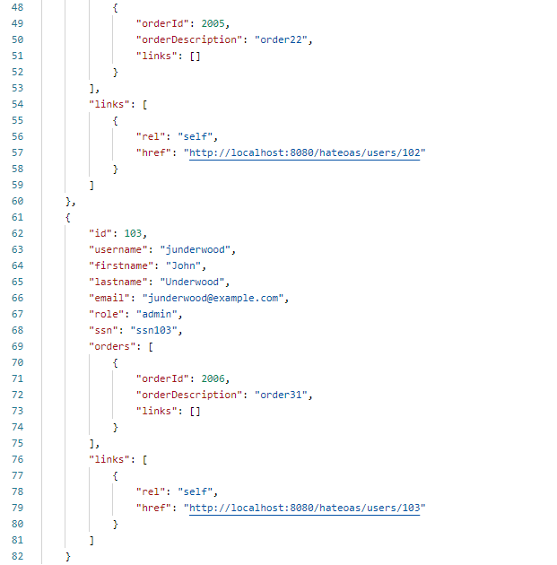

**Step-05: Implement self relationship links in getAllUsers Method in UserHateoasController**

* **5(A) Self Link for each user in a for loop**
  + **UserHateoasController**
  + **Method: getAllUsers**
  + **HATEOAS: Implement self linking for each user**
    - **For loop**
    - **Extract User**
    - **Create Link with WebMvcLinkBuilder**
    - **Add Link**
    - **Change Return Type to ResponseEntity<User> Users**
* **Test using POSTMAN**
  + **Method: getAllUsers**
  + **GET /hateoas/users**
* **5(B) RelationShip Link with getAllOrders**
  + **UserHateoasController & OrderHateoasController**
  + **Method: getAllUsers**
  + **HATEOAS: Implement relationship linking for getAllOrders**
  + **OrderHateoasController** 
    - **Change getAllOrders method return type to ResponseEntity<Order> from List<Order>**
  + **UserHateoasController**
    - **Create link with WebMvcLinkBuilder**
    - **Add Link**
* **Test using POSTMAN**
  + **Method: getAllUsers**
  + **GET /hateoas/users**
* **5(C) Self for getAllUsers**
  + **UserHateoasController**
  + **Method: getAllUsers**
  + **HATEOAS: Implement self-linking for getAllUsers method**
  + **OrderHateoasController** 
    - **Create link with WebMvcLinkBuilder**
    - **Add Link to CollectionModel and return model**
* **Test using POSTMAN**
  + **Method: getAllUsers**
  + **GET /hateoas/users**

**OrderHateoasController populating Link for getAllOrders():**

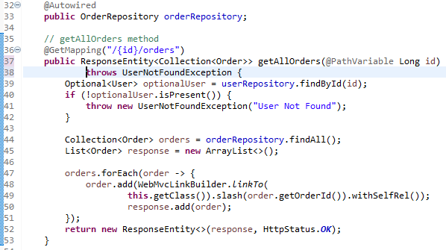

**Test with POSTMAN**

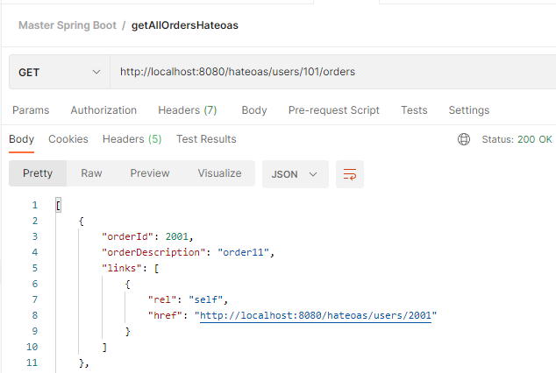

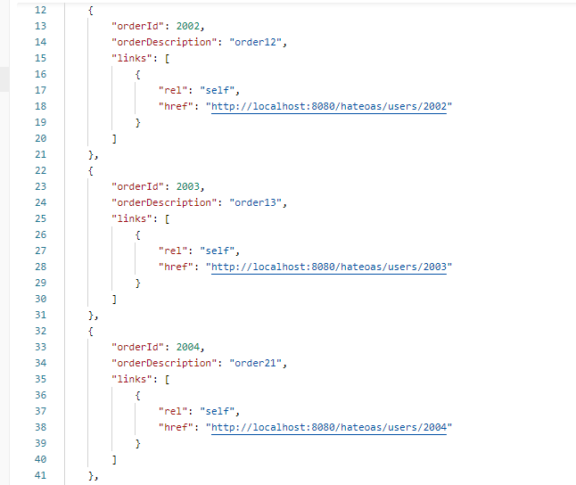

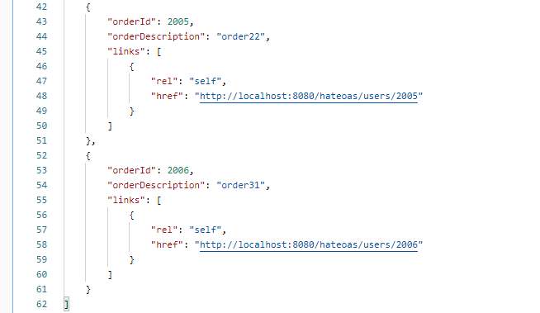

**Adding the all-orders to getAllUsers():**

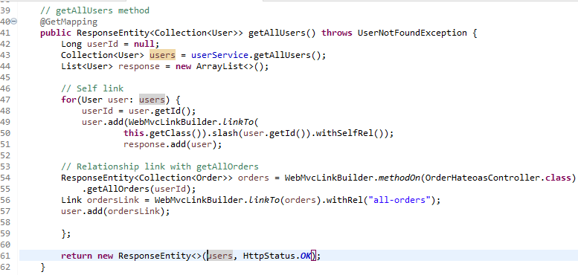

**Test with Postman:**

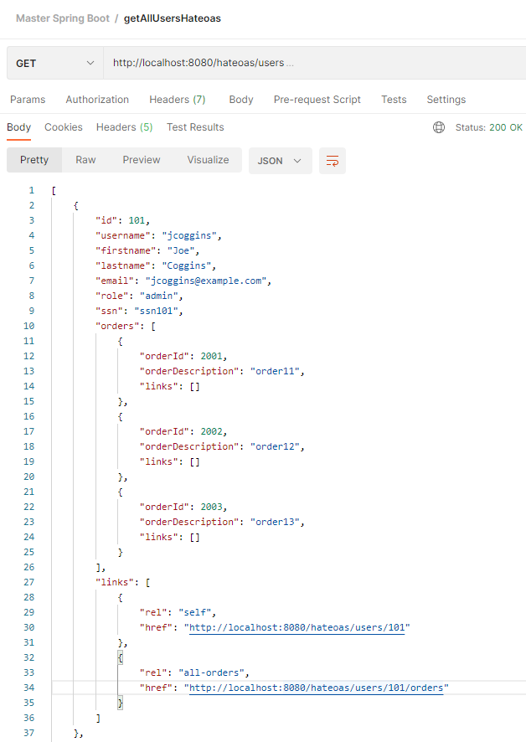

**Add a link to the end of the Users for getAllUsers:**

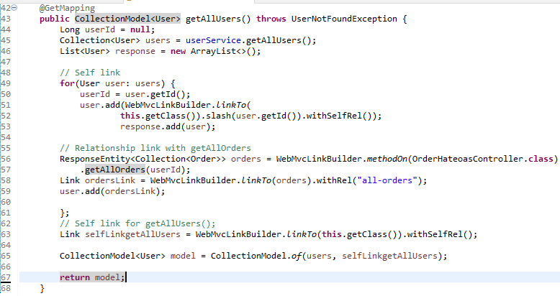

**Test using PostMan:**

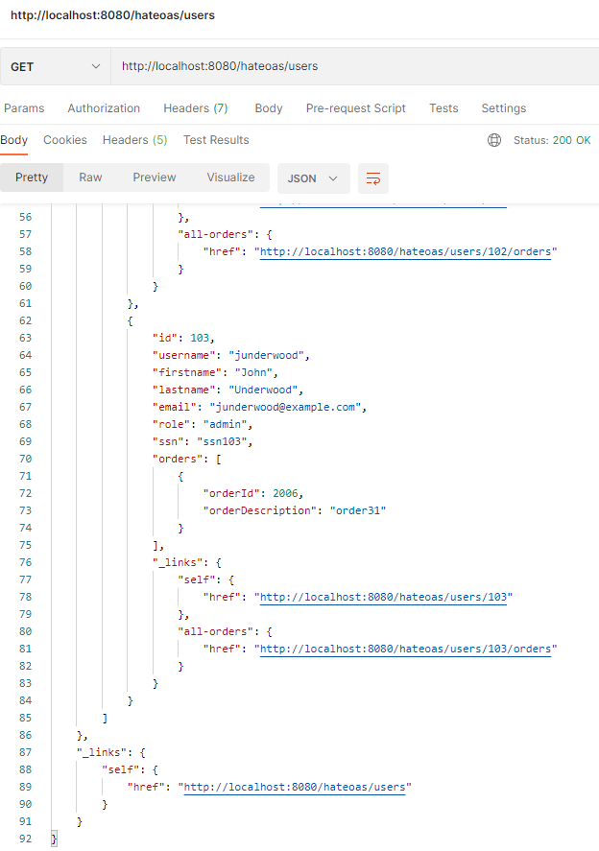

**Step-06: GIT commit code, push to remote, merge to master and push to remove (master)**

* **git status**

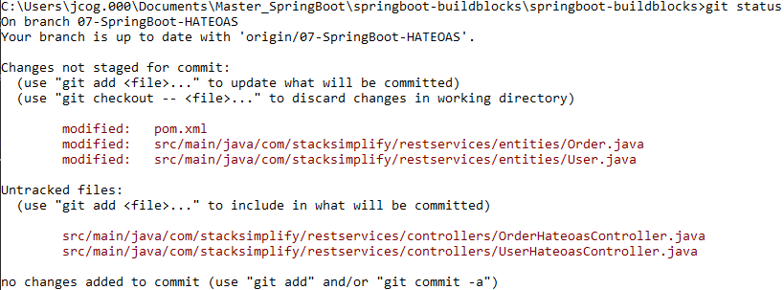

* **git add . git status**

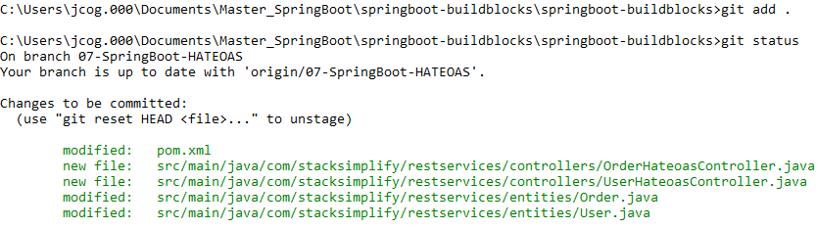

* **git commit –am “HATEOS – First Commit”**

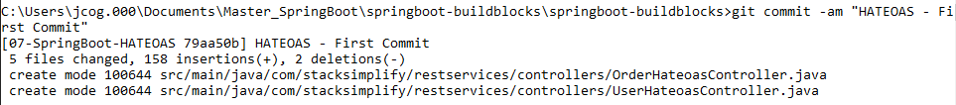

* **git push**

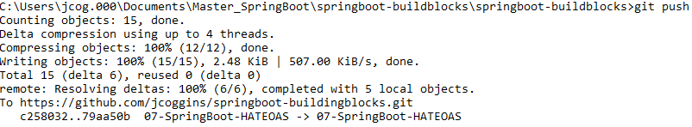

* **git checkout master**



* **git merge 07-SpringBoot-HATEOAS**

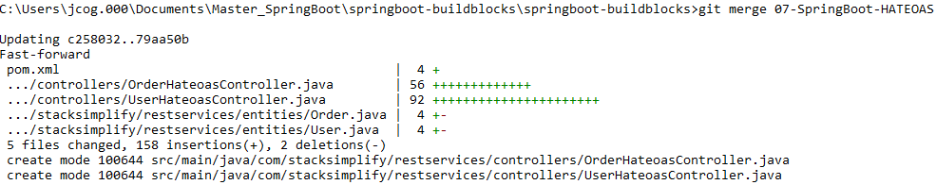

* **git branch –vva**

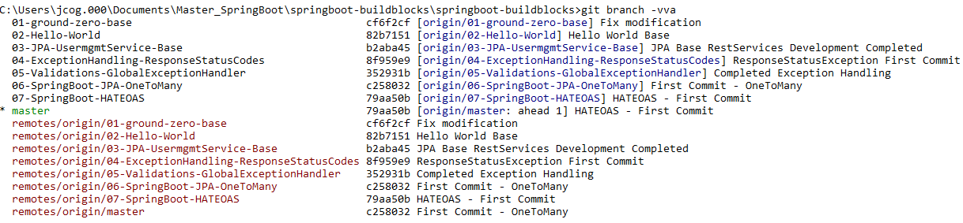

* **git push**



* **git branch –vva**

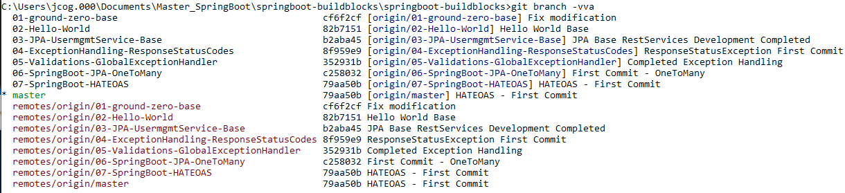

**All 4 branches are the same (local branch, local master | remote branch, remote master) are all 79aa506**

**Added getOrderByIdHateoas and corrected getAllOrdersHateoas:**

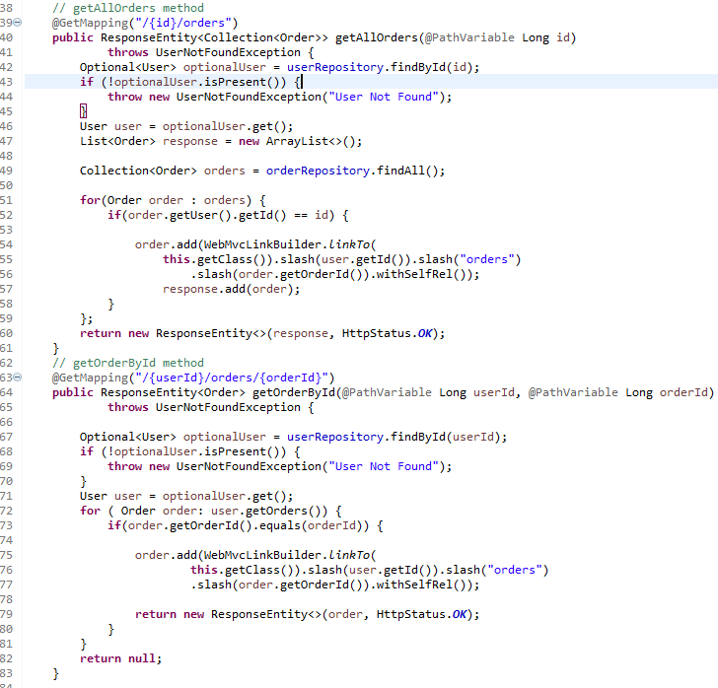

**Step-07: GIT commit code, push to remote, merge to master and push to remote**

**git commit –m “Fixed getAllOrders”**